ARTIFICIAL INTELLIGENCE CHATBOT
Submitted By
Name: Mitushi Jain
Internship: CodeAlpha Java Programming Internship

1. Objective
The objective of this project is to develop a Java-based Artificial Intelligence Chatbot that can interact with users and provide responses to commonly asked questions. The chatbot uses rule-based logic to understand user input and generate appropriate replies.

2. Tools Used
- Java
- JDK (Java Development Kit)
- Visual Studio Code
- Command Prompt / Terminal

3. Project Description
The Artificial Intelligence Chatbot is a console-based application developed using Java. The chatbot communicates with users through text-based conversations. It recognizes predefined keywords and responds accordingly. The system demonstrates basic concepts of Artificial Intelligence, Natural Language Processing, and human-computer interaction.

4. Features
- Interactive user conversation.
- Responds to common greetings.
- Answers frequently asked questions.
- Simple rule-based response mechanism.
- User-friendly console interface.
- Exit command to end the conversation.

5. Working Procedure
- The program starts and welcomes the user.
- The user enters a message.
- The chatbot analyzes the input text.
- It searches for matching keywords.
- Based on the keyword, an appropriate response is generated.
- If no keyword is found, a default response is displayed.
- The conversation continues until the user types "bye".

6. Algorithm
- Start the program.
- Display a welcome message.
- Read user input.
- Convert input to lowercase.
- Check for predefined keywords.
- Generate corresponding response.
- If the user enters "bye", terminate the program.
- Otherwise, continue the conversation.
7. Output Screenshots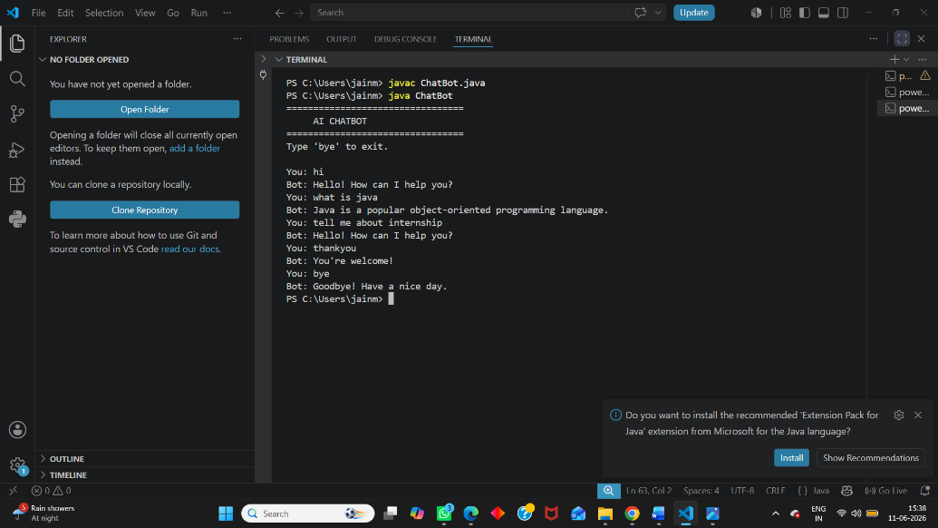

8. Advantages
- Easy to use.
- Demonstrates basic AI concepts.
- Provides instant responses.
- Helps understand chatbot development.
- Beginner-friendly Java project.

9. Limitations
- Uses predefined responses.
- Cannot learn from users.
- Limited conversational ability.
- No real NLP model integration.

10. Future Enhancements
- Integration with Machine Learning.
- Voice-based interaction.
- GUI-based chatbot interface.
- Database support for storing conversations.
- Advanced NLP processing.
- Web and mobile deployment.

11. Conclusion
The Artificial Intelligence Chatbot successfully demonstrates basic chatbot functionality using Java. It interacts with users through predefined responses and provides an understanding of chatbot development concepts. This project helps in learning Java programming, user interaction, and introductory Artificial Intelligence techniques.

12. References
- Oracle Java Documentation
- Java Programming Tutorials
- Artificial Intelligence Fundamentals
- CodeAlpha Internship Guidelines

